Day15 LSP 5/8/24

File Manipulation using System Calls in C++ on Linux Objective: Create a C++ program that performs file manipulation using Linux system calls. The program should be able to: Create a new file. Write a specified string to the file. Read the contents of the file and display them on the console. Append additional text to the file. Delete the file. Requirements: Use system calls like open, read, write, close, and unlink. Handle errors appropriately by checking the return values of system calls and using perror to print error messages. Ensure the program is modular with separate functions for each file operation (create, write, read, append, delete).

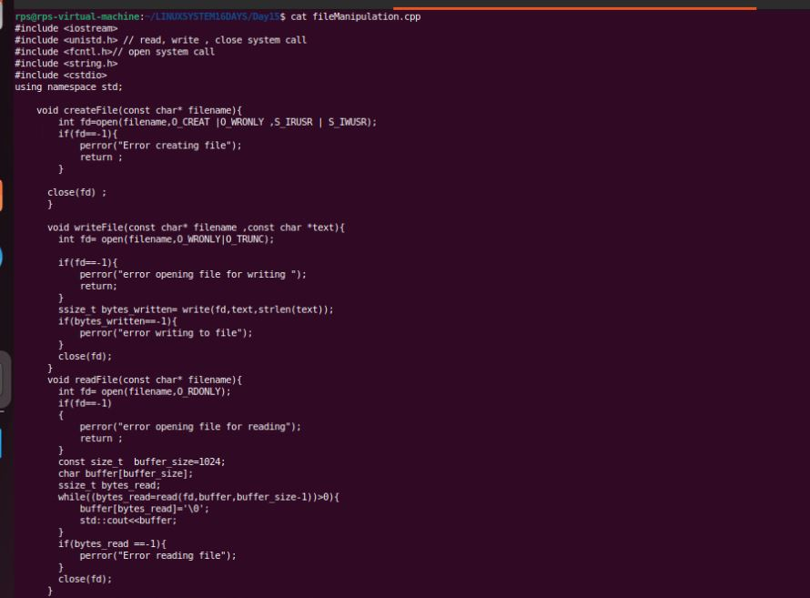

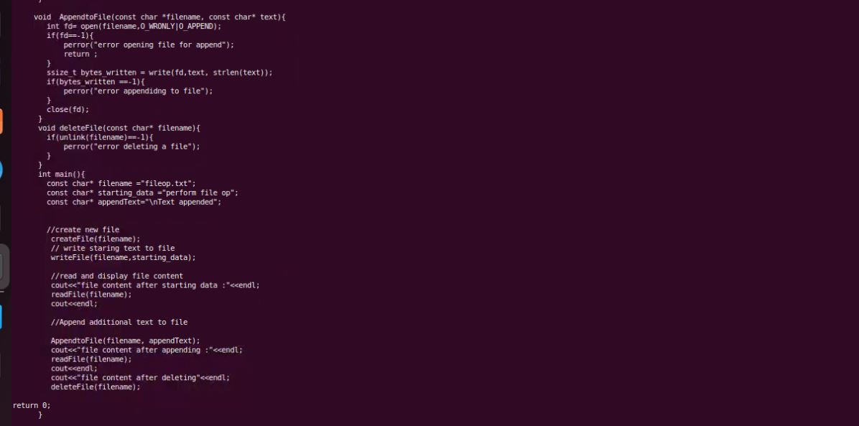

Output

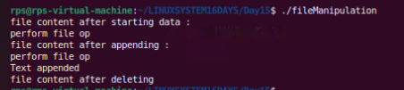

UDP SERVER CLIENT CHAT

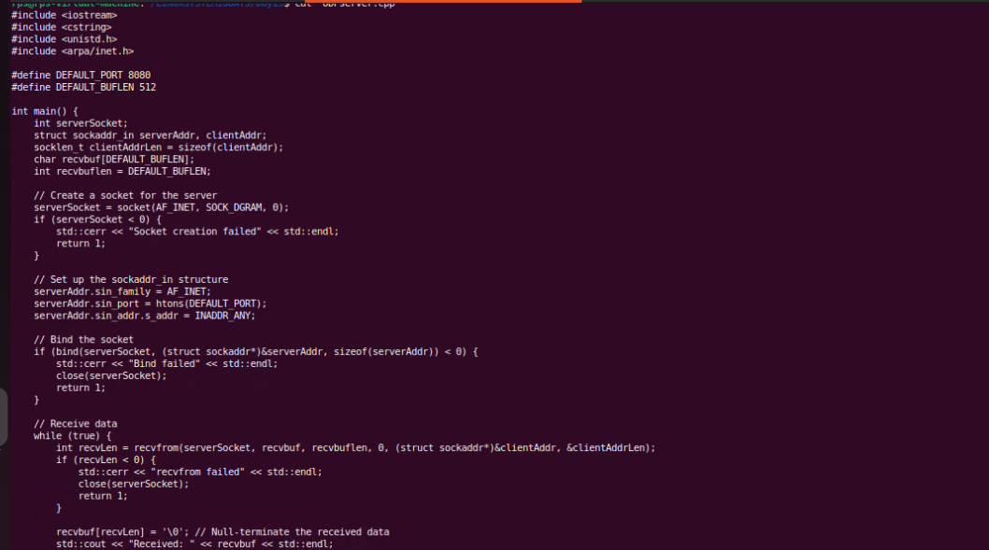

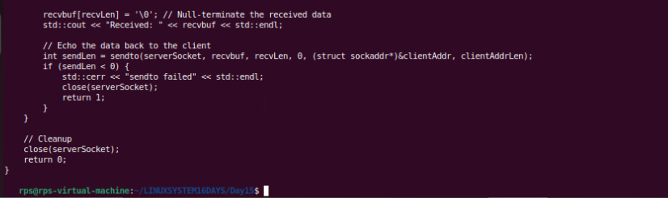

OUTPUT



UDP CLIENT

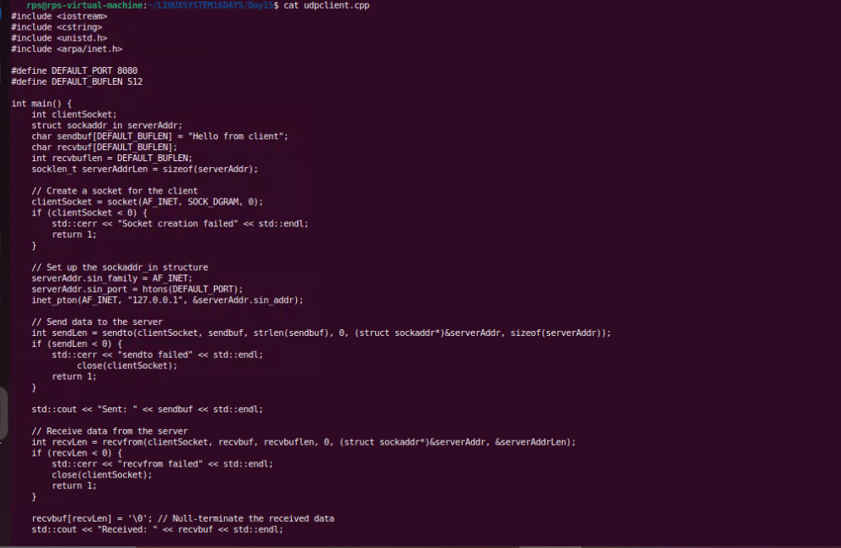

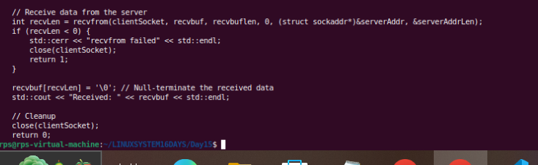

OUTPUT

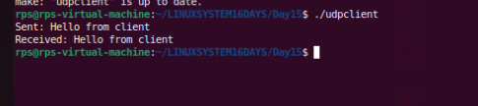

Task2 UDP Server Implementation:

Create a UDP socket.

Bind the socket to a specified port.

Implement a loop to continuously listen for incoming messages.

Upon receiving a message:

Print the received message along with the client’s address and port.

Send an acknowledgment message ("Message received") back to the client.

Ensure proper error handling and resource cleanup.

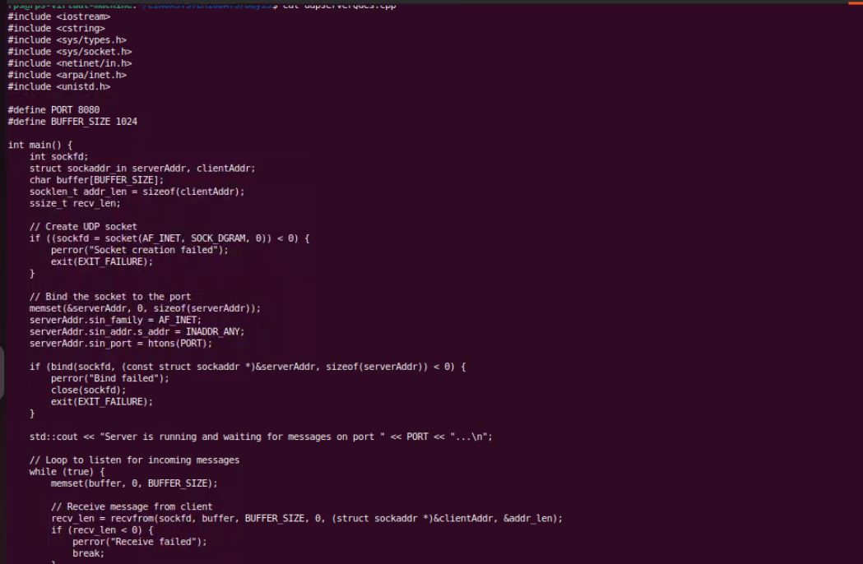

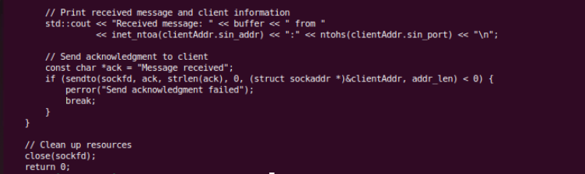

Output



UDP CLIENT

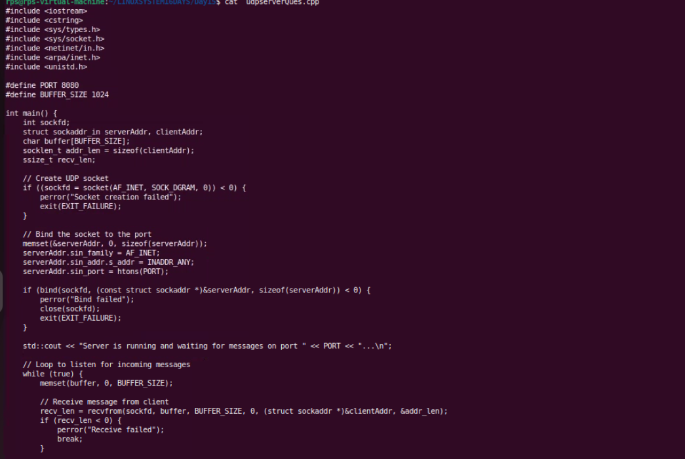

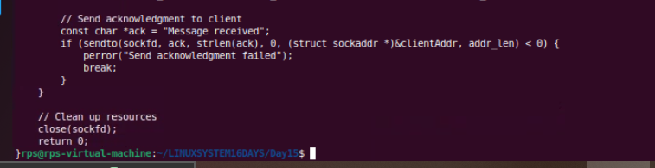

OUTPUT

